**Steps to Install Django for Windows 10**

**\*\*\*\*\*\*\*\*\*\*\*\*\*\*\*\*\*\*\*\*\*\*\*\*\*\*\*\*\*\*\*\*\*\*\*\*\*\*\*\*\*\*\*\*\*\*\*\*\*\*\*\*\*\*\*\*\*\*\*\*\*\*\*\*\*\*\*\*\*\*\*\*\*\*\*\*\*\*\*\*\*\*\*\*\*\*\*\*\*\*\*\*\*\*\*\*\*\*\***

**Step 1: Install Pyhton in your System Version > 3 according to your System requirement**

**Download Link:** [**https://www.python.org/downloads/**](https://www.python.org/downloads/)

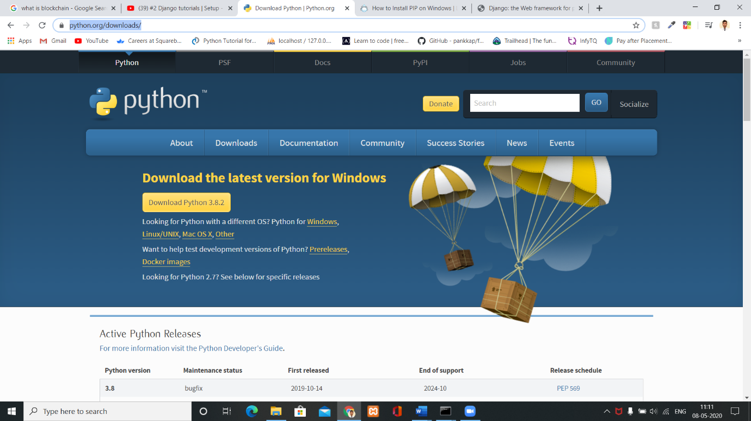

**Step 2: Check weather Python installed or not using Command line interface(cmd)**

**>> python --version**

**Step 3: Check weather pip is installed or not in your system using Command line interface(cmd)**

**>> pip --version**

**Step 3.1: If pip not installed in your System then use this command to install it-**

**>> python get-pip.py**

**Step 4: Check if django installed in your system or not using cmd-**

**>> django-admin --version**

**Step 5: If Django not installed in your system first create virtual space for your project**

**For creating virtual space install virtualenvwrapper using cmd-**

**>> pip install virtaulenvwrapper-win**

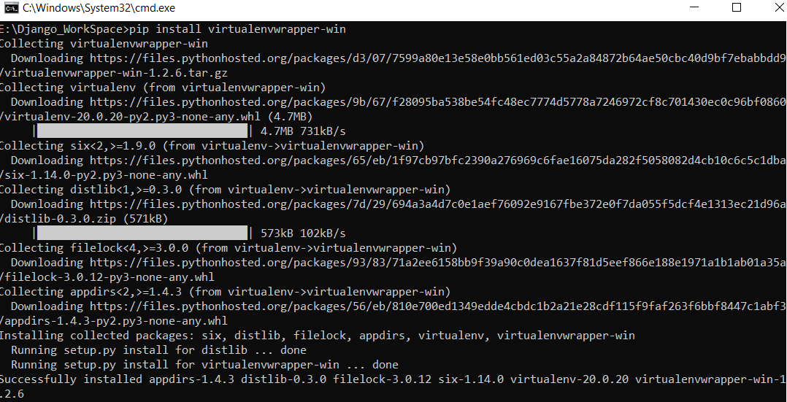

**Step 6: After installing virtual environment create virtual environment-**

**>> mkvirtualenv environment name**

**Example:**

**>> mkvirtualenv test // here test is the name of an environment**

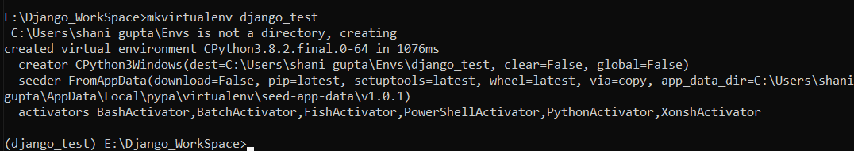

**Step 7: After create an environment install Django using cmd-**

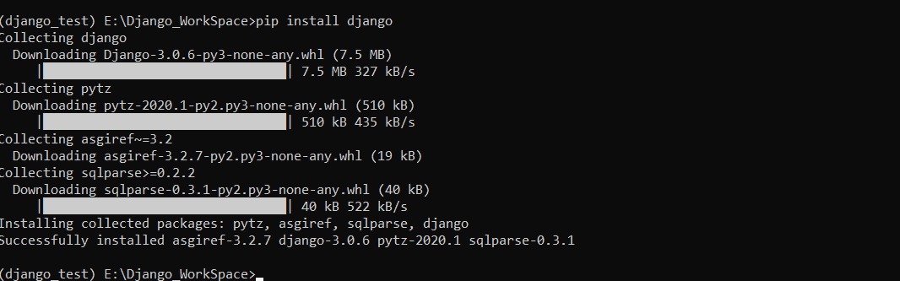 **>> pip install django**

**Check weather Django installed or not using cmd-**

** >> django-admin –version**

**Step 8: After that you have to create one folder where you can create your first project –**

**>> mkdir foldername**

**After that use following command to change directory**

**>> cd foldername**

**Step 9: Now let’s create our first Django project using cmd-**

**>> django-admin startproject projectname**

**Example:**

**>> django-admin startproject MyApp**

**Step 10: After creating the project change the directory using cmd-**

**>> cd MyApp**

**Step 11: And finally start you server to run this particular project**

**>> python manage.py runserver**

**Copy this IP address and paste it into your browser search bar**

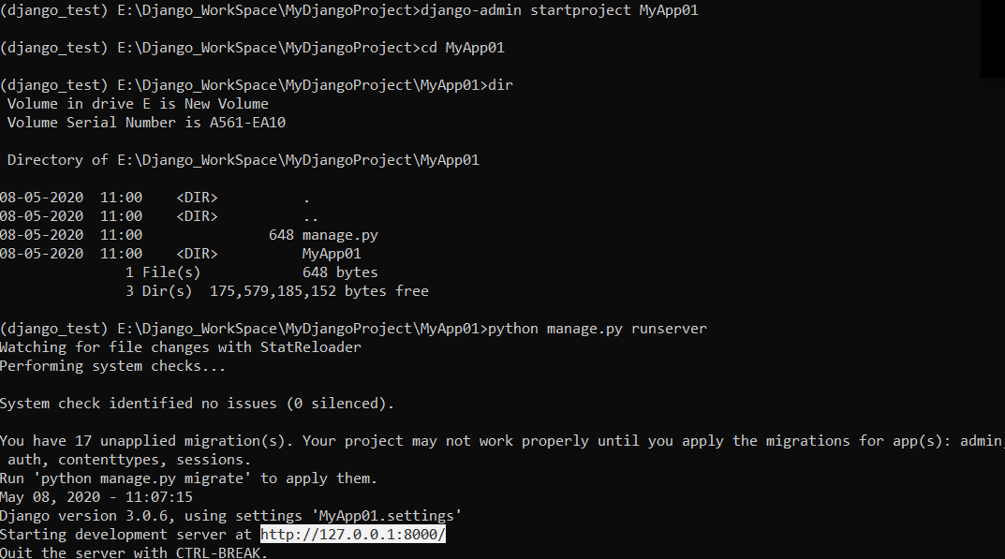 [**http://127.0.0.1:8000/**](http://127.0.0.1:8000/)